Assignment 1

Ishaq Khan

INFS 6353

11/1/2023

1. Word Cloud of the comments. Theres not a lot because the video I chose was a more viewed video but slightly less comments. I tried using the Get_All_Comments for a much larger video but I was not able to get the results desired. Nonetheless, this Word Cloud revolves around comments about Laptop Hardware by Professor Messer.

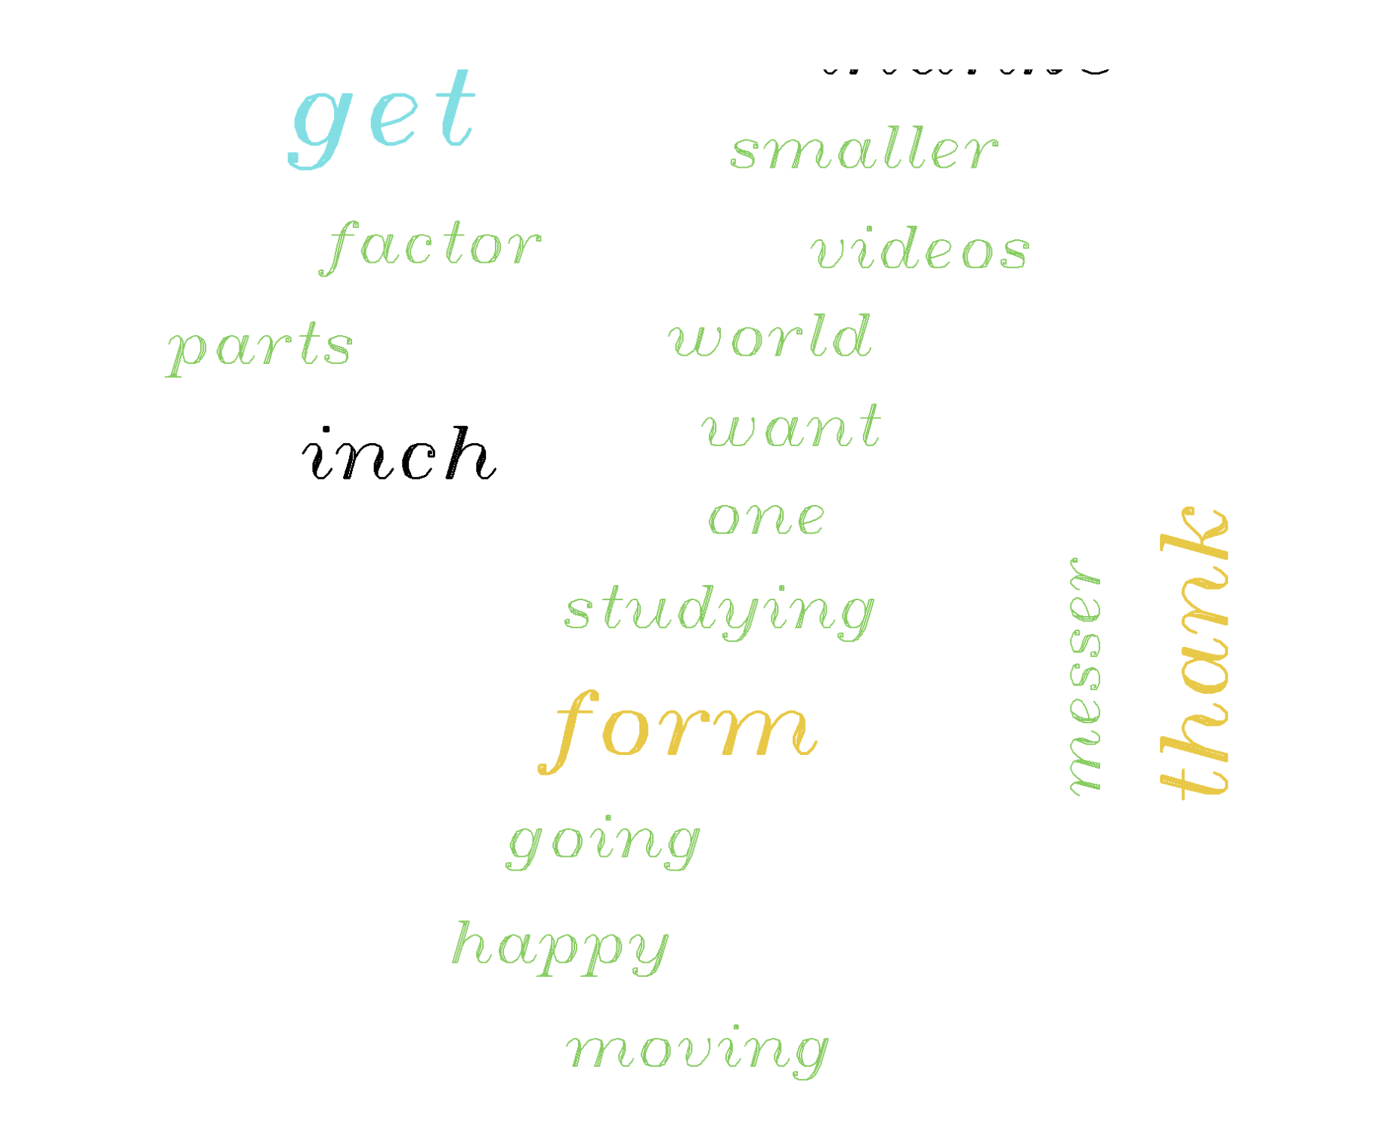

1. Barplot of the Emotions in the comments. This chart plots the emotions and their frequency. We can see where some emotions are present a lot more than others. For example, the frequency of anticipation is much higher than that of anger. This can give you an idea of what the comment section emotional range is and how some are more frequent than others.

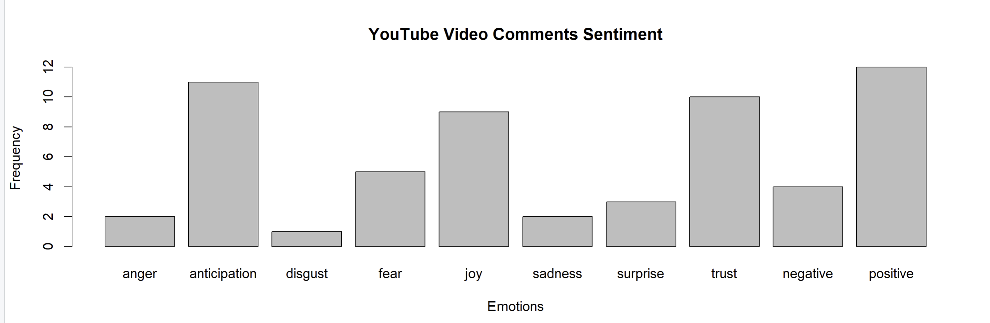

1. Lastly, this is Single Parity score for each comment. This gives each comment a single sentiment score. If there are positive values, it indicated positive sentiment. If there are negative values, then it indicates that there is a negative sentiment. As for this video, there are 3 negative sentiment comments, but their value is not significantly large to where it indicates that the “severity” of that negative sentiment is massive. All of them are under -1.0, which is indicated a more positive sentiment across the comments.

1. Here are videos a list of videos.

1. Here are the channel statistics for The Race. They are a motorsports content channel that reviews and reports on motorsport news.

1. Here are handful of thousands of thousands of comments on all videos on the channel. There were so many comments on the channel that it would be time consuming adding all of the thousands of comments.

And lastly, this is the word cloud of the comments that showed up. What is great to see is how pretty much every word in there is related to the videos and content that the channel produces. You can see words about the factory they built the cars in, the names of different countries they raced in, and even some Formula 1 drivers like Alonso.

